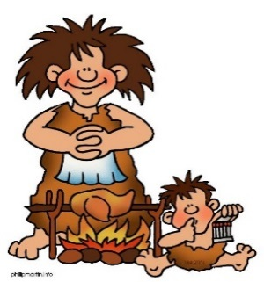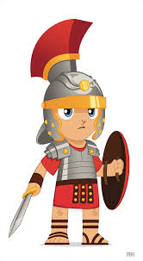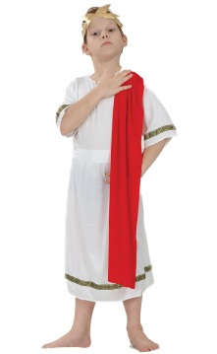

**Music**

Music this half term will be covered by Samba, which is taught by a specialist music teacher. This focusses on listening skills, awareness of rhythm and performance confidence.

**Outdoor Learning**

This half term we will be continuing outdoor learning by making Stone Age tools and jewellery using Cornish Palm leaves to make string.

**P.S.H.E.**

This half term we will be learning with others. The children will have tasks to complete as part of a group and they will take on different roles in their group.

**MFL**

The children will be learning about the different rooms in the house as well as revising what they have already learnt about food, animals and family.

**Maths**

This half term we will be working on solving sequences and place value understanding. We will also revise the written methods we have learnt for addition, subtraction, multiplication and division as well as introducing more advanced methods. The children will apply their knowledge of these methods to money too. Finally we will investigate how to work out area and perimeter, as well as finding co-ordinates.

The children are also being given real life maths problems each week to solve in groups. This gives the children a chance to talk about how to solve problems as well as providing a real life context to use maths.

**English**

In English this half term we will be writing haiku poems about our new topic. The children will create their own word banks and count how many syllables the word has before we write our haikus.

We will also be learning the story Stone Age Boy. In this story a boy joins a Stone Age tribe in their struggle for survival. He learns how they lived their everyday life and how they would hunt with spears. We will then write our own story about what we would learn if we lived in a Bronze Age or Iron Age tribe.

**Writing target:**

To start sentences with an adverbial.

**P.E**

This term we will be improving our tennis skills. We will also be working on our ball handling skills and coordination. Swimming will happen on a Monday morning throughout this term.

**D&T and Art**

We will be making our own paint for cave paintings on paper and experiment with painting onto rocks and slate.

We hope to recreate some of the cave paintings we have seen as well as doing our own versions of animals.

**Reading and Spelling**

The class will read their books in school and we listen to individual readers each day. We continue to use Accelerated Reader as an assessment of children’s comprehension.

As we draw closer to the end of the year the children will be given more advanced spellings in lessons. We will also practise the words that they have struggled with in the past as well as practise our phonics understanding with games.

**Geography and History**

This half term in history we will be studying the different periods of time in prehistory. The children will find out how we have learnt about these periods of time when there is no writing to record what happened. Finally we will make a comparison of the ages for how people lived.

**Science**

This term will we be learning about how plants grow. We will be experimenting with different conditions plants need to grow and we will be planting our own seeds of different plants. We will also look at how plants reproduce and disperse their seeds.