Weekly Newsletter
Summer 3, May 5th 2017 www.penponds.cornwall.sch.uk
01209 713929
secretary@penponds.cornwall.sch.uk
@Penponds_School
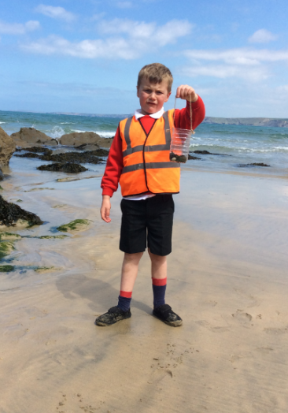  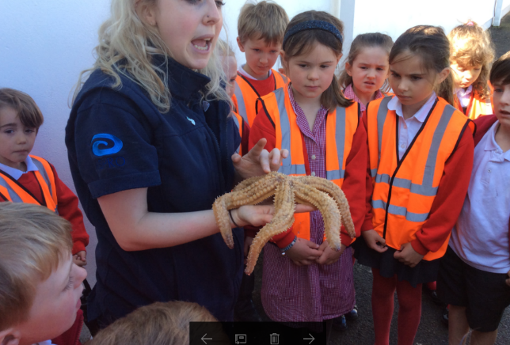  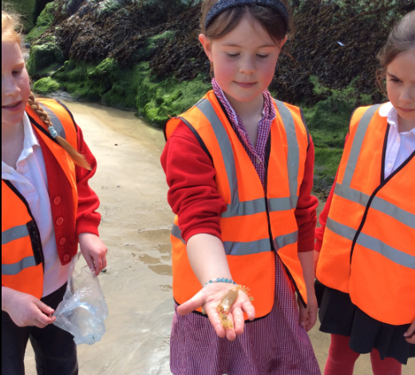  This week’s focus: visit to Newquay Aquarium  On Tuesday, as part of their topic learning, Carn Brea and Godolphin classes went on the coach to visit Newquay Aquarium and have lunch on Towan beach. Emilia said, “it was a great trip and I loved it because of all the animals”. Lilli said, “I saw all the turtles which were really cute”. Thank you to the mums and dads who came along as parent helpers to take such a big group on a visit.  Bunny Bingo  Last Friday Friends of Penponds School organised Bunny Bingo in the school hall. It was a mammouth session of fundraising. Thank you to all the parents for supporting the event and the generous donations received on the night.  Read, Write Inc training  This week six of our staff attended Read, Write Inc training to ensure we remain up to date on how we teach phonics in school. There were many new ideas to incorporate into our practice and assurance that the methods we use at school remain on the cutting edge of reading education in school.  Ofsted at The Rainbow MAT  Ofsted have been busy within the Rainbow MAT this term with recent inspections at Troon and St Meriadoc Junior schools. Troon’s report has been published and is available here: http://www.troon.cornwall.sch.uk/website/our-performance/37631  I am very proud of the staff at both schools who continue to work extremely hard to achieve fantastic outcomes for the children in our area.  Trevithick day  Last Saturday our pupils led the dance through Camborne as part of the Trevithick day celebrations. The children had been practising in their own time and looked resplendent in their red bonnets and waistcoats. Our display, ‘Innovation on Cornish Mining’, included work from Trencom and Tregonning classes as well as a selection of engine houses made at home by the children. This was set up in the Masonic hall by Miss Souch. We won the display competition and were presented with a trophy bigger than the FA cup on Wednesday! Mrs Stone organised the children, sorted the costumes and taught them the dance so deserves much credit. Thank you to all the parents who were involved in bringing the children on Saturday morning and those who have emailed photos of the day into school See the report in this week’s West Briton. http://www.cornwalllive.com/camborne-s-trevithick-day-impresses-thousands-of-spectators/story-30302194-detail/story.html  Penponds Family Festival – Save the date  Our first Penponds Family festival will take place on FRIDAY 7th JULY from 3.30pm. There will be stalls, live music, school fete type activities and food. All the money raised from the festival will go towards improving the outside areas of the school. We are keen to get as many stall holders in as possible – if you would like to book a table for the festival (or know anyone who may like to) please e mail secretary@penponds.cornwall.sch.uk  PAG – raffle prizes list:  Accelerated Reader update  Congratulations to our new word millionaire this week – Emily Jones. Our total words read and understood has now beaten the total of 24 million from last year with still ¾ of a term to go! Thank you for all the reading at home which is really inspiring the children to quiz on lots of books.  Maths challenge from Lee Dunstan  Netball report  Summer term clubs  Please see the link for our summer term clubs: http://www.penponds.cornwall.sch.uk/web/after_school_clubs/143886  School uniform second hand sale  Summer term clubs  Please see the link for our summer term clubs: http://www.penponds.cornwall.sch.uk/web/after_school_clubs/143886  School uniform and PE kit school/hats  Please can all parents ensure the children are in the correct school uniform every day in school.  http://www.penponds.cornwall.sch.uk/web/_school_uniform/143933  The school has a large stock of ‘lost property’ in the garage if your child is missing any items. Please make sure all items are clearly labelled with your child’s name. School shoes must be black.  DfE consultation on Primary Assessment changes  You may have heard in the news that the Government is consulting on changing the way assessments are carried out in primary schools. If you wish to have your say, here is link:  https://consult.education.gov.uk/assessment-policy-and-development/primary-assessment/  Fundraising through Battery collection  The school is now able to collect old batteries for recycling. The collection box is just inside the entrance door – please place any old batteries in the box and the school will receive money for each batch of batteries that are collected. Many thanks. | Dates for your diary:  Mon 8-12 May – SATS week – Year 6  Mon 15-19 May – SATS week – Year 2  Tues 16th May – Maths information evening for parents  Fri 26 May – London Trip meeting for parents at 3.30pm  Mon 29 May – Fri 2 June – School Closed - Half Term  Mon 5 June – Sports Day – Class 1+2  Mon 19-21 June – London Residential – Class 4  Wed 28 June – Rainbow MAT Sports Day at Penponds School  Mon 3-5 July – Carnyorth Residential – Class 3  Fri 7th July – Penponds Family festival  Tue 25 July – Last Day for pupils  Wed 26 July – INSET DAY – School closed to pupils  Mon 4th Sep – INSET DAY – School closed to pupils  Tue 5th Sep – First day of Autumn Term  This week’s awards:  Top Table :  Class Awards:  Carn Brea:  Godolphin:  Trencom:  Tregonning:  Headteacher Awards:  Attendance:  Carn Brea:  Godolphin:  Trencrom:  Tregonning:  Attendance Trophy:  Quote of the week:  Sainsbury's Active Kids vouchers  We are now collecting active sports vouchers from Sainsbury's to help us buy new sports and cooking equipment for the children. Our collection box is situated just inside the sliding door of the foyer. Please send in the vouchers with the children. Many thanks for your support.  School Text Messaging  Service  We are now able to text  message parents; we will start using this service in the coming weeks. Initially only urgent texts will be sent, e.g. if a football game is cancelled. For more details, please see:  http://www.penponds.c ornwall.sch.uk/web/text  _messaging_service  The ‘Extreme Reading Challenge’ is simple. Make sure as parents you are reading with your child as much as possible during the week and sign their diaries. On a Friday any child who has read every day that week at home will have their name put into a draw for some, ‘Extreme Reading’ prizes. If possible, include a photo of them reading a book in an interesting location! Good-luck everyone!

