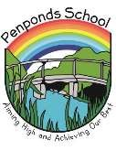
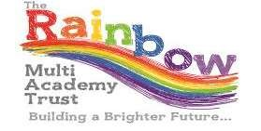
Weekly Newsletter
Autumn 14 Friday 14th December 2018
www.penponds.cornwall.sch.uk
01209 713929
secretary@penponds.cornwall.sch.uk
@Penponds_School
This week’s focus: Christmas  Christmas Carol Concert - Friday 7th December  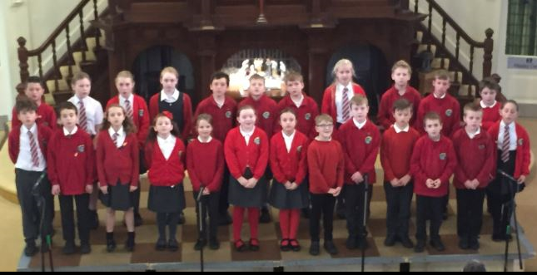  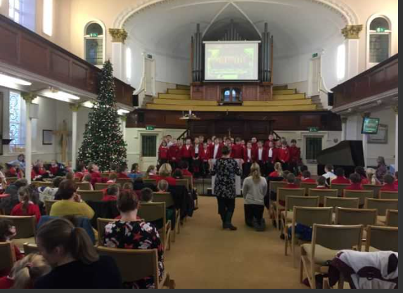  On Friday 7th December the whole school had its annual Christmas carol concert. I think it was the best one yet! The whole thing kicked off at 6.30pm but the children had to be there by 6pm. Our Whole School songs were, Mary had a Baby, It was a Starry Night and Mr Richard’s favourite – Little Drummer Boy! Not forgetting our fabulous speakers, Gina, Amy, Lloyd, Jasmine, Ellena, Ruby, Lilly, Thomas, Piran, Jessica, Harvey, Keira, Alice and last but not least, Vincent. Wow! What a lot of people! Tregonning Class used their ukuleles to play Rudolf the Red-nosed Reindeer with Mr Fields, sang their song, the St Day Carol AND included loads of people in the speaking situation! Trencrom Class sung their song, We Three Kings. Godolphin Class sang A Christmas Candle and, of course, not forgetting Carn Brea Class who sang Away in a Manger! There was a lot of work put into this carol concert, so a HUGE thank you goes to all the teachers who organised and planned the whole thing! Also a special thank you to Mrs Holmes for helping us sing and for playing the piano for us! Merry Christmas and a very Happy New Year! By Lilly  Spelling Bee  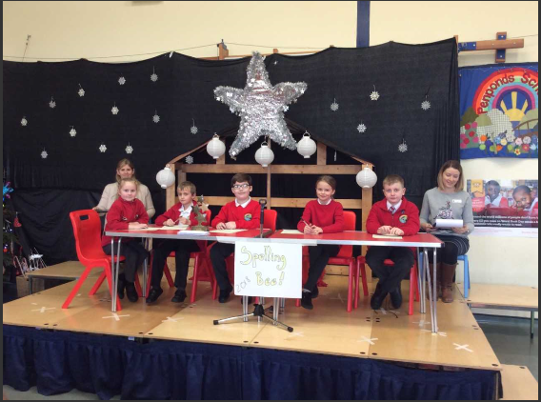  Wow! What a fantastic first spelling bee here at Penponds school! All the children worked so hard and the words were incredibly tough. Our finalists, Bella, Jasper, Ben, Jasmine and James did a fantastic job, with our overall winner being Ben Hoccom. Well done Ben!  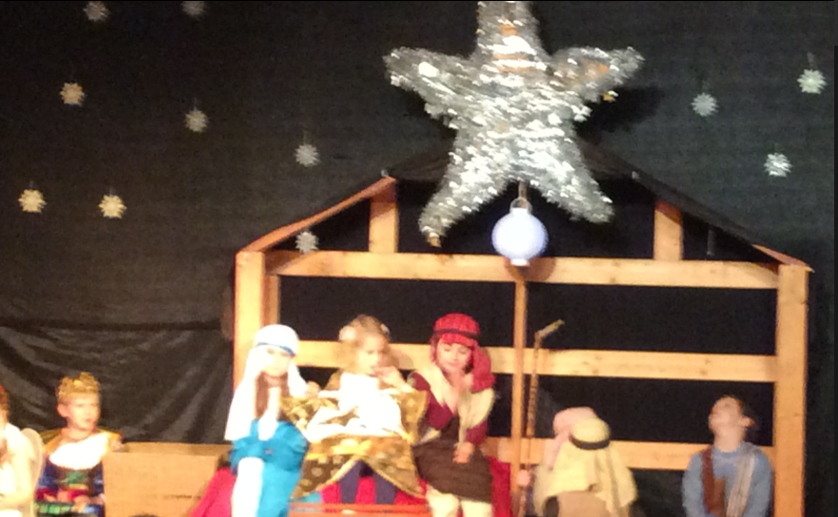  Children of the world  This week, children in Carn Brea and Godolphin class performed their Christmas play, Children Of The World, and what a job they did! All the children were absolutely amazing and we are so proud of them. We’d also like to say a huge thank you to all the parents who provided wonderful costumes. The children really enjoyed themselves and worked so hard and it really showed! Well done everyone!  Penponds Church – Carn Brea Class  On Tuesday Carn Brea class walked to Penponds church.  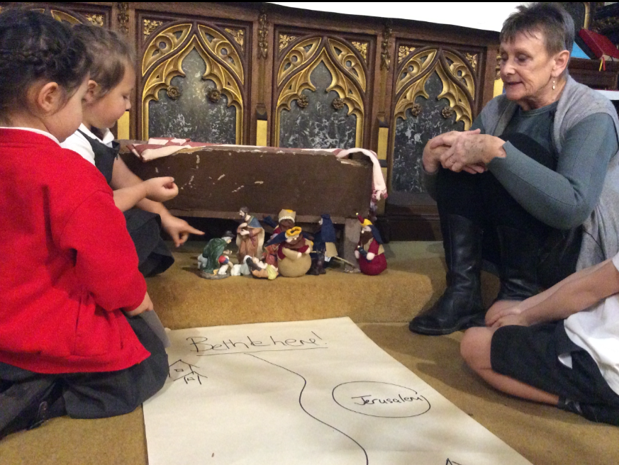  We had a lovely time learning about the Christmas story. Thank you to Olive and all her helpers for teaching us the story behind the celebrations.  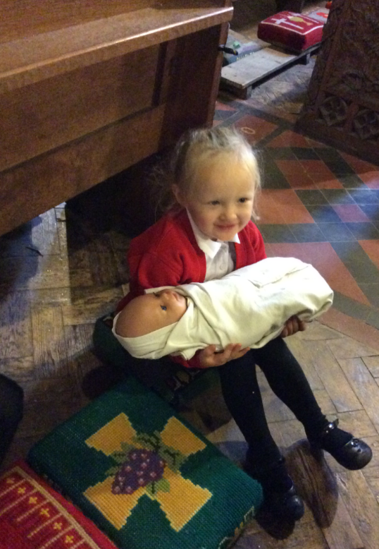  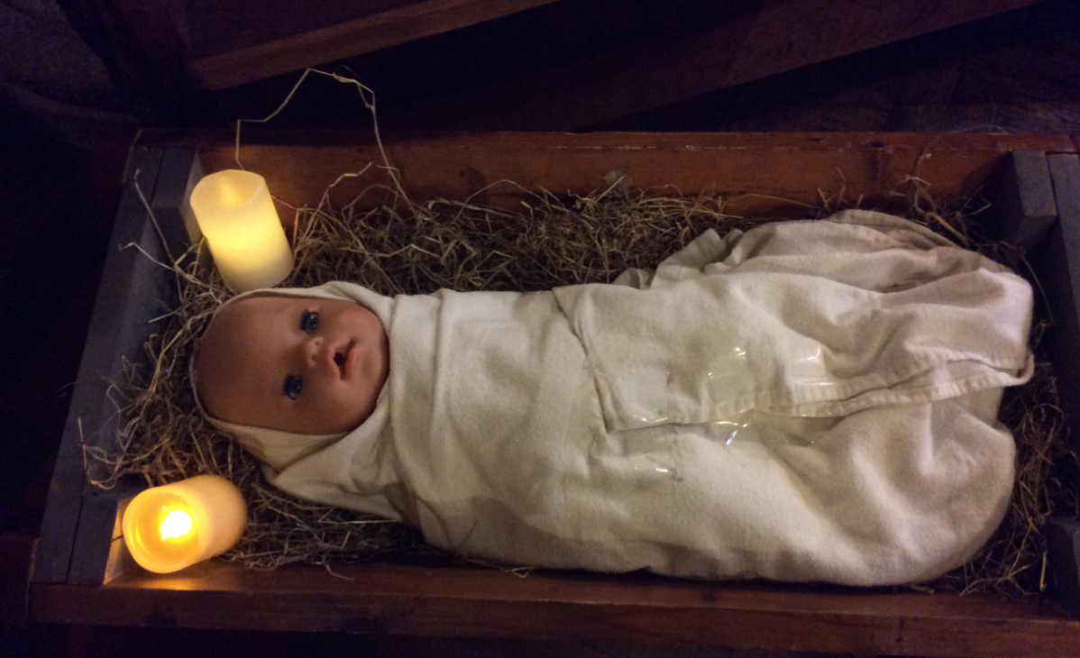  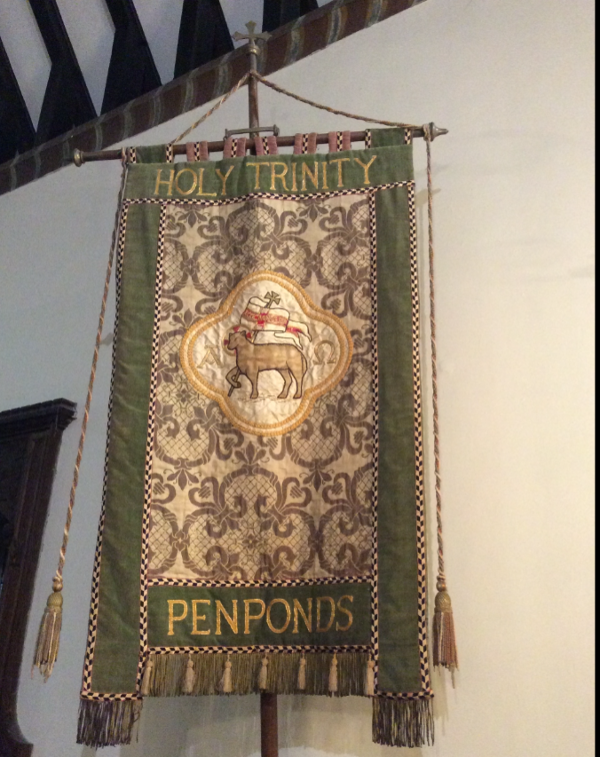  Penponds Church – Trencrom Class  On Thursday 13th December Class 3 went to Penponds Church for Christmas Activities. First we went down to the church and we walked passed the grave yard into the church. Our first activity was the Message. It was mostly about shepherds and sheep and thinking about a world that was all peace.  The next one was the Journey. We thought about how long it took to get from Nazareth to Bethlehem. We all picked up a king, shepherd, donkey, Mary and Joseph and thought about how they felt when they heard there was a new born king.  The next one was the Gift. We thought about all the gifts that the shepherds and kings brought. Also we thought what we would bring Jesus and we saw a model of the stable and everything in it.  The next one was the Agreement we learnt that Mary cleaned with a broom made out of wood and she made bread out of salt and flour.  The next one was Promises. We thought about different promises people made. There was a promise that said “He will be called Prince of Peace”. They were really fun to read.  The next one was Preparation. It was about candles. There were 5 different coloured candles and you light one when there’s 4, 3, 2, or 1 week left. Then you light the 5th candle on Christmas Day.  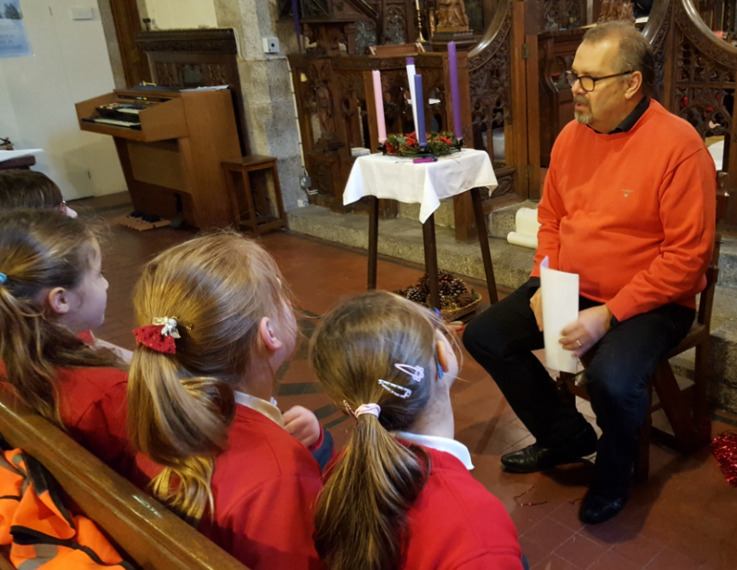  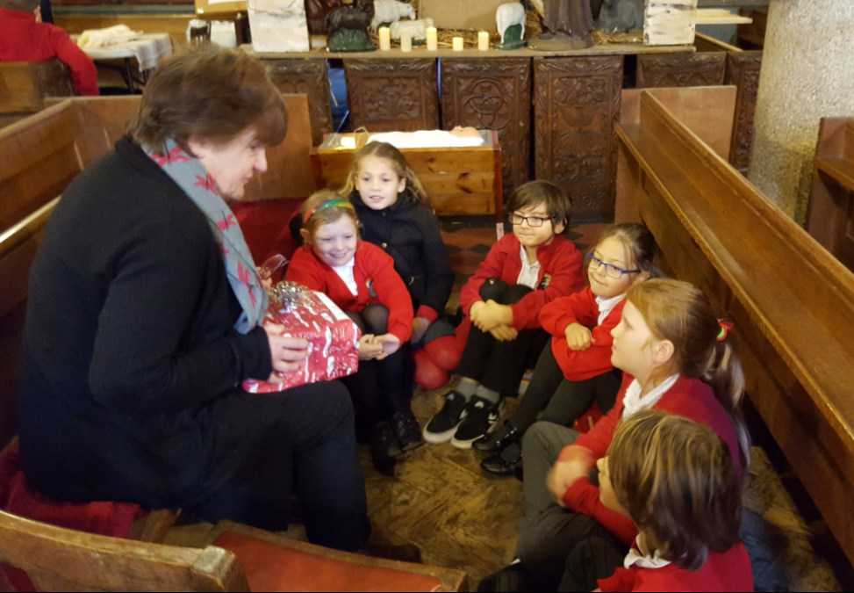  The Christmas workshop was fun and everyone enjoyed it. It was interesting and we learnt a lot. By Vincent and Hollie  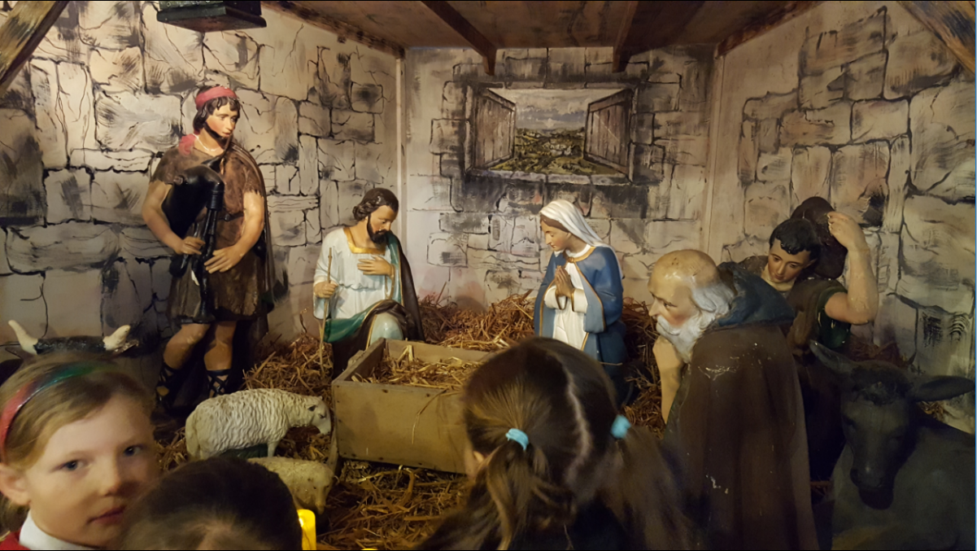  Choir visit to Tregenna Nursing Home  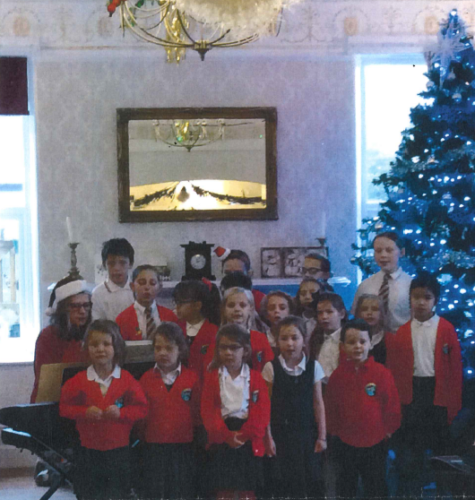  On Thursday 13th December, the Penponds school choir went to Tregenna Nursing home and performed to an audience. It was really fun and we sang plenty of our favourite Christmas carols including, Away in a Manger, Come on Christmas and a few others. At the end, the kind nurses gave us a bag of sweets that we very much enjoyed. We are very grateful to Mrs Holmes for playing the keyboard and making our songs lively and fun. By Ruby and Alice  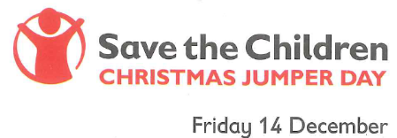  Save the Children’s Christmas Jumper Day – Friday 14th December  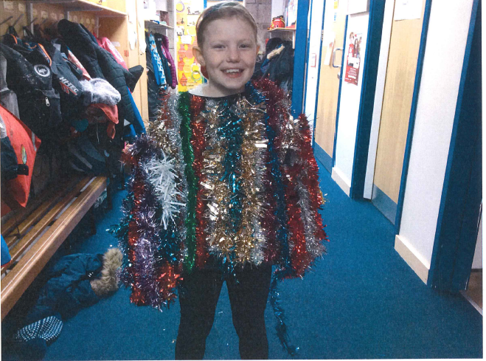  Today we all wore a Christmas jumper or something Christmassy to raise money for Save the Children. This event was organised by Gina in Tregonning Class. There were some amazing jumpers and outfits and everyone had a lot of fun! We raised £90. Thank you very much to everyone for their generous donations.  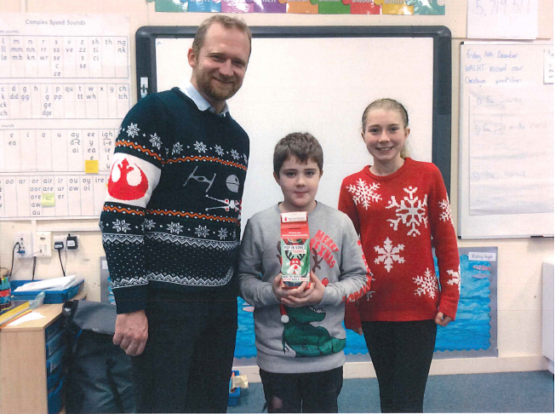 | Dates for your diary:  Friday 14th December – Penponds Tree Lights switch on at 6pm – village event – everyone welcome  Sunday 16th December – Penponds Village Nativity at 4pm – Village Event – everyone welcome  Monday 17th December – NO Football Club after school  Tuesday 18th December – NO Choir after school  Monday 17th December – NEXUS Maths Masterclass 8.55am  Monday 17th December - Family Lantern Making in the hall – Whole school  Wednesday 19th December – Christmas Dinner – whole school  Wednesday 19th December – Last day of school for children  Wednesday 19th December – Camborne Lantern Parade – 6.30-7.30pm  Inset Days:  Thursday 20th December 2018  Monday 7th January 2019  Friday 5th April 2019  Thursday 25th July 2019  Tuesday 8th January 2019 – First day back for children  Monday 14th January – Trencrom Class start swimming lessons  Thursday 25th and Friday 26th January – Bikeability for Year 5 children  Monday 28th January – NEXUS Maths Masterclass 8.55am  Monday 11th February– NEXUS Maths Masterclass 8.55am  Monday 4th March  NEXUS Maths Masterclass 8.55am  Monday 18th March  NEXUS Maths Masterclass 8.55am  Monday 1st April  NEXUS Maths Masterclass 8.55am  Monday 29th April  NEXUS Maths Masterclass 8.55am  Monday 13th May  NEXUS Maths Masterclass 8.55am  Friday 12th July 2019 – Penponds Family Festival  Attendance:  Carn Brea: 89.44%  Godolphin:  Y1 – 98.04%  YR2 – 100%  Trencrom: 97.39%  Tregonning: 96.58%  Attendance Trophy:  Y2 Godolphin Class  Awards:  Top Table – Jessica R, Charlie, Lloyd, Hollie S  Carn Brea – Mack, Orla, Holly  Godophin –  Y1 – All of Year 1, Maisy, Toby  Y2 – All of Year 2, Harry, Isla,  Trencrom – Jessica, Jowan, Finley  Tregonning – Jasmine, James, Lemmy  Headteacher – Isla, Olivia, Abbie, Kaira, Oliver, Elijah H, Jasmine C, James, Bella, Ben H, Jasper L-L  Maths – Lilly, Harrison, Laurie, Esmee, Emily Q  Children’s University - Joshua  Quote for this week:  A little smile, a word of cheer, a bit of love from one held dear and best wishes for the coming year. These make a Merry Christmas!
