2019/ 2020 Reception and Year 1 Reading Challenge– starting after Half Term!

Dear Reception and Year 1 Parents,

We would like to tell you about our fantastic reading incentive for children in Reception starting after half term. To further support your child’s progress in reading it is essential that children read regularly aloud to an adult. This ensures that your child has someone listening as they use their sounds to blend and read words. As your child’s reading develops children can enjoy reading aloud longer texts and discussing what they have read. Sharing and discussing books with someone everyday will ensure your child’s confidence and ability in reading will grow and grow along with a life-long love of books and reading.

How the Reception Reading Challenge works:

* The Reading Challenge is to track how many times your child reads aloud to an adult every week.
* The number of reads totals a reading prize.
* The more your child reads and has their diary signed the quicker they progress to collect prizes before the highly acclaimed prize of a book voucher.

We really hope you enjoy supporting your child in reaching their goal for reading. Please see overleaf for more details. We can’t wait to hand out the first set of prizes very soon.

Many Thanks for your continued support.

Miss Souch Literacy Lead

**Reception/ Yr 1 Reading Challenge Rules**.

* Try to read every day.
* Read a minimum of 4 pages to count as one read.



* Only 1 read will be counted per day.
* Parents **MUST** sign each read in the reading record and colour in the symbol on the grid below.

|  |  |  |
| --- | --- | --- |
| Autumn start date 28th October | Earliest Date | |
| ☺ ☺ ☺ ☺ ☺ ☺ ☺ ☺ ☺ ☺ ☺ ☺ ☺ ☺ ☺ ☺ ☺ ☺ ☺ ☺ 20 reads | 16.11.19 | Prize 1 |
| ☺ ☺ ☺ ☺ ☺ ☺ ☺ ☺ ☺ ☺ ☺ ☺ ☺ ☺ ☺ ☺ ☺ ☺ ☺ ☺ 30 reads  ☺ ☺ ☺ ☺ ☺ ☺ ☺ ☺ ☺ ☺ | 16.12.19 | Prize 2 |
| ☺ ☺ ☺ ☺ ☺ ☺ ☺ ☺ ☺ ☺ ☺ ☺ ☺ ☺ ☺ ☺ ☺ ☺ ☺ ☺ 40 reads  ☺ ☺ ☺ ☺ ☺ ☺ ☺ ☺ ☺ ☺ ☺ ☺ ☺ ☺ ☺ ☺ ☺ ☺ ☺ ☺ | 25th January | Prize 3 |
| ☺ ☺ ☺ ☺ ☺ ☺ ☺ ☺ ☺ ☺ ☺ ☺ ☺ ☺ ☺ ☺ ☺ ☺ ☺ ☺ 50 reads  ☺ ☺ ☺ ☺ ☺ ☺ ☺ ☺ ☺ ☺ ☺ ☺ ☺ ☺ ☺ ☺ ☺ ☺ ☺ ☺  ☺ ☺ ☺ ☺ ☺ ☺ ☺ ☺ ☺ ☺ | 14th March | Prize 4 |
| ☺ ☺ ☺ ☺ ☺ ☺ ☺ ☺ ☺ ☺ ☺ ☺ ☺ ☺ ☺ ☺ ☺ ☺ ☺ ☺ 60 reads  ☺ ☺ ☺ ☺ ☺ ☺ ☺ ☺ ☺ ☺ ☺ ☺ ☺ ☺ ☺ ☺ ☺ ☺ ☺ ☺  ☺ ☺ ☺ ☺ ☺ ☺ ☺ ☺ ☺ ☺ ☺ ☺ ☺ ☺ ☺ ☺ ☺ ☺ ☺ ☺ | 13th May | Prize 5 |

In addition to listening to your child read we recommend these fantastic books to share and read aloud to your child whilst in Reception.

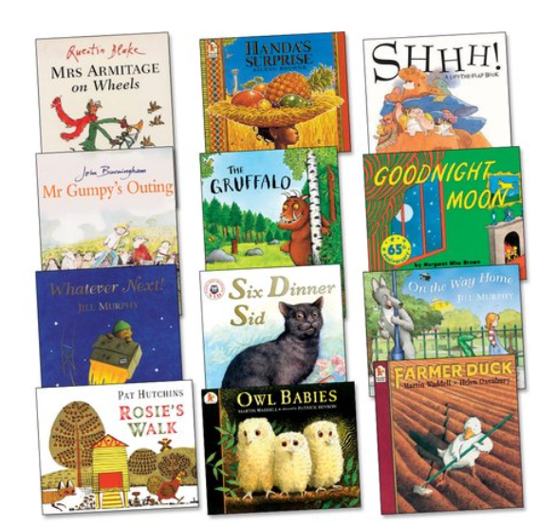

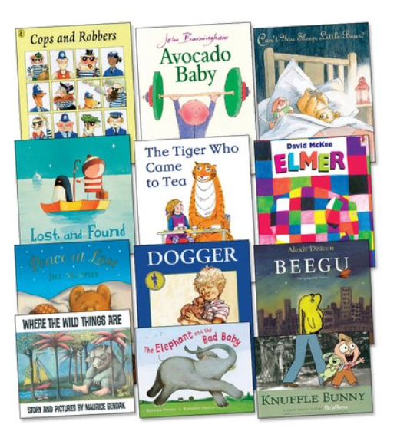

In addition to listening to your child read we recommend these fantastic books to share and read aloud to your child whilst in year one.

In addition to listening to your child read we recommend these fantastic books to share and read aloud to your child whilst in year two.

