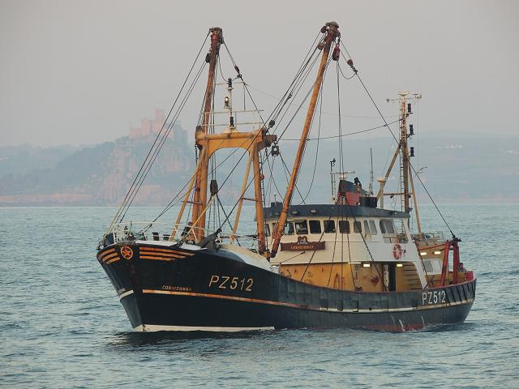

**How you can help your child:**

Visit and explore together the following websites:

<http://fishandkids.msc.org/en>

[www.bbc.co.uk/science/habitats/](http://www.bbc.co.uk/science/habitats/)

<http://www.sciencekids.co.nz/sciencefacts/animals/fish.html>

<http://animals.nationalgeographic.com/animals/fish/>

Discuss any news items about our topic. Celebrate your child's effort with their homework.

Take them to visit fishing ports like Newlyn, St. Ives, Falmouth and look at the fishing boats. Show them the fish counter at Tesco Extra (or elsewhere!) and have a go at cooking and eating fish at home.

**Computing**

* E-safety
* Powerpoint presentations
* Information posters about fish

This will be taught by Miss Percy and Mrs Treen

**Non-Fiction**

* Diary entries
* Non chronological reports
* Instructions

**Drama**

* Talk for Writing
* Debating
* Performance of the Mousehole Storm-Cat

**Geography – Fish for the future**

* Local industry
* Sustainable fishing programs
* Communities around fishing
* Newlyn Fish market visit
* Impact on ecosystems.
* Looking at environmental issues and how we can help.

The main topic input will be from Mrs Treen

**Poetry**

* Similes and Metaphors
* Descriptive vocabulary

**Literacy**

**Fiction:**

* Story-telling- the Mousehole Cat
* Descriptive writing
* Writing in character and from own point of view: 1st and 3rd person narrative

**Texts:**

* The Mousehole Cat

**Science – Nutrition and Sounds**

* How humans and animals need food to survive
* Eating healthily and food groups
* Muscles and the human body
* How exercise affects the body
* How sounds are made
* Changing and controlling sounds
* Making musical instruments

Science will be taught by Miss Percy on Thursday afternoons

**Trencrom Class –**

**Year 3/4 Spring term 2019**

**Fish for the Future**

**Local Geography**

**Maths**

* Place value of numbers up to 1000 (10,000 for year 4)
* Addition and subtraction using place value
* Addition and subtraction using written methods such as partitioning and a number line
* Number bonds to 20
* Counting on in multiples of 10 and 100 from any starting point
* Multiplication and division of 1 and 2 digit numbers.
* Properties of shapes
* Finding fractions of shapes and numbers, placing fractions on a number line.

**Music – developing musical instruments**

* Ukelele lessons
* Sea Shanties

This will be taught by Mr Field, a music specialist

**RE –**

Christianity, the Cornish rebellion, St. Piran and Christian celebrations

This will be taught by Miss Meyers

**D&T – cookery**

Exploring different flavours of fish and creating a fish pie.

This will be taught by Mrs Treen after half term

**Art – watercolours and pastels**

* Newlyn Artists
* Looking closely at fish, patterns and colours.
* Mixing and blending colours
* Penlee Gallery visit

This will be taught by Mrs Treen

**PHSE –**

e-safety, friendships and getting on, feelings and being kind

**PE – Swimming**

This will continue throughout the Spring term on a Monday afternoon