Dear Parents

World Book Day 2017 – Thursday 2nd March

On Thursday 2nd March it will be World Book Day! We always like to celebrate the day in style at Penponds School so we will be inviting everyone to come to school dressed up as their favourite book character and donate a book for a whole school book swap.

In addition to this children in Tregonning and Trencrom Classes will be working with artist and printmaker Dena O’Brien creating limited edition prints. These designs will then be pieced together following the workshop and made into a single edition handmade book by a traditional bookmaker.

Godolophin and Carn Brea will also be having lots of book themed fun in their classes too. Children will be creating illustrations, baking, storytelling and sharing their favourite books.

Snuggledown with a good book: In the evening, from 5.30pm to 6.45pm, all the children are invited back into school in their pyjamas and slippers (with their teddies) to listen to the staff read their favourite stories. Areas of each classroom will be transformed into a cosy, dimly-lit living room with a roaring fire (on the board projector!) and the children will be spilt into mixed aged groups and rotate through the different stories. Towards the end of the evening FOPS will provide everyone with a hot chocolate before the children are picked up at 6.45pm. In order to get an idea of numbers for Snuggledown please complete and return the attached slip or email Mrs Woods at: secretary@penponds.cornwall.sch.uk.

We would also like to use World Book Day to launch our new incentive for reading at home regularly. Reading at home aloud daily is essential in developing confident reading and comprehension skills. Reading with your child is the most important homework and way of supporting your child’s learning. Children are already collecting reading karate bands and reaching their targets in Accelerated Reader but we feel we need to raise the bar further so that all children are ‘Extreme Readers’ at Penponds School. The ‘Extreme Reading Challenge’ is simple. Make sure as parents you are reading with your child as much as possible during the week and sign their diaries. On a Friday any child who has read every day that week at home will have their name put into a draw for some, ’Extreme Reading’ prizes. If possible, include a photo of them reading a book in a interesting location! Some examples are below. Good-luck everyone!
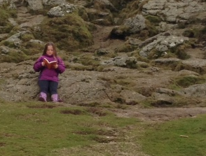
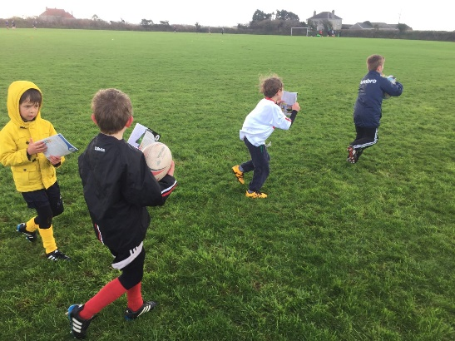

Yours Sincerely

Miss C Souch
Literacy Subject Leader

WORLD BOOK DAY SNUGGLEDOWN

I would like___________________________(name of child) to attend Snuggledown in school from 5.30pm to 6.45pm on Thursday 2nd March.

I will collect my child at 6.45pm.

