Penponds School SEND information report for Special Educational Needs and Disability 2018/2019

At Penponds Primary School we welcome everyone into our School Community. We all work together to make our school a happy, welcoming place where children and adults achieve their full potential: Aiming High and Achieving our Best. We make this happen by focusing on the individual needs, providing a purposeful learning environment that enables all children to make the greatest possible progress and achieve their best in a caring, supportive and fully inclusive environment.
Our SEND provision allows pupils with learning difficulties the opportunity to follow a curriculum specifically tailored to develop skills for life, a sense of wonder about the world around them, to maximise their potential and to work independently.
We are committed as a school community to narrowing the attainment gap between SEND and non-SEND pupils. This can include anything from short-term intervention to personalised out of school learning opportunities.
All children and young people are entitled to an education that enables them to make progress, be confident individuals living fulfilling lives, make a successful transition into adulthood and above all be ‘curious, creative and confident’.
School profile
Number of children with SEN academic year 2018/19
Class | SEN support 1 | SEN support 2 | EHC plan | Total
Reception | 1 | 1 | 1 | 3
Year 1 | 1 | 2 | 1 | 4
Year 2 | 0 | 1 | 1 | 2
Year 3 | 4 | 0 | 0 | 4
Year 4 | 4 | 0 | 0 | 4
Year 5 | 4 | 0 | 1 | 5
Year 6 | 1 | 1 | 0 | 2
Total |  |  |  | 24

Progress of children with SEN
SATs results Year 6 academic year 2017/18 cohort
Number in cohort | Number on SEN register | SEN support 1 | SEN support 2 | EHC plan
15 | 2 | 1 | 1 | 0
2018 8% of pupils at SEN support 1 8% of pupils at SEN support 2 and 0% with a statement or EHC plan.
Out of the children eligible to take SAT’s
SEN support1 (1) | School (progress KS1-KS2)
Maths | 12.3
Reading | 14.3
Writing | 2.5
SPAG | N/A
SEN support2 (1) | School
Maths | 2.6
Reading | 2.1
Writing | -8.4
SPAG | N/A
Statement or EHC plan (0) | School
Maths | N/A
Reading | N/A
Writing | N/A
The Kinds of SEND that are provided for:
We refer to the term ‘Special Educational Needs’ if a child:
- Has significantly greater difficulty in learning than the majority of children of his or her age in one or more areas of learning.
- Has a difficulty which either prevents or hinders him or her from making use of educational facilities of a kind generally provided in schools within the area

The difficulties or disabilities may relate to:
- communication and interaction
- cognition and learning
- behavioural, emotional and social development and mental health
- sensory or physical conditions

Current Types of SEN at Penponds School
Dyslexia Sensory processing Attachment disorder Speech and language problems Autism
Downs Syndrome Visually impaired cognition and learning Cerebal Palsy EAL
Special Education Provision is that which is additional to or different from that which is made generally for most children in school by quality first teaching.
Assessment is an on-going process throughout the school. It is a check that each child is making adequate progress against the national expectations set for each year group. If a child is not making expected progress then we identify a need and determine the reason why.
Adequate progress is defined as that which:
- closes the attainment gap between the child and children of a similar age
- prevents the attainment gap growing wider
- is similar to that of peers starting from the same attainment baseline, but less than that majority of their peers
- matches or is between the previous rate of progress
- ensures that a child has full access to the curriculum in line with their peers
- demonstrates an improvement in self-help, social or personal skills
- demonstrates improvement in a child’s behaviour allowing them to be receptive to learning

How we identify children and assess their needs:
Our school promotes the graduated ‘action and intervention’ approach to support children to help them succeed. We recognise that there is a continuum of SEND with different levels of support needed, but also ensuring that each individual child’s needs are supported.
Throughout our school from entry in Year R our children are assessed to check their progress in English and Maths. It is through this process and our teacher assessments that we are able to identify children who are not making expected progress, highlighting them and putting into place appropriate actions. Teachers, support staff and parents are vital in raising concerns about barriers to learning, this can include behaviour, social and emotional matters.
As a school we track out children’s progress and continually use this to identify need. If a child fails to make expected progress the next step is to identify interventions of actions that can be taken. This is identified by teachers, the Extended Leadership Team or the SENDCo. We incorporate these procedures into our normal working practice.
Following assessment and staff consultation of a child’s special needs are identified and the needs are recorded on the SEND register.
Specialists from outside school meet with parents and school staff to hold review meetings at least annually in addition to parent meetings support teachers.
How we consult with parents of children with SEN
Here is a flow chart showing the steps we take to support children with SEND. We only move from one step to another if a child still needs more support and is not making sufficient progress. If a child makes excellent progress, we may decide to move back a step.
Step 1 – Initial Concern -Parents and/or teachers raise concerns about a child. Concerns are discussed between parents or carers and the class teacher. The SENCo will be made aware of these early concerns.

Step 2 – Teacher Adapts- The class teacher adapts work and/or re-organises classroom support to help the child make better progress.

Step 3 – IEP- A child’s needs are assessed in detail and an IEP (Individual Education Plan) is developed with the SENCo. School resources and/or expertise may be assigned to deliver the IEP and from now onwards we will use a graduated approach to meeting children’s needs (see next section).

Step 4 – Early Help Assessment- The SENCo arranges a TAC (Team Around the Child) meeting and invites parents and outside specialists to come along and help us to carry out an EHA (Early Help Assessment). We need lots of information from parents at this stage to help us to fully understand the child. The information we collect, helps us to plan very closely to meet the needs of children. Plans made will be reviewed through another TAC meeting and we will all decide what to do next.

Step 5 – Education and Health Care Plan- If it has been agreed by everyone at step 4, we will apply for an EHCP (Education and Health Care Plan) from the County. This replaces the old ‘Statement of Special Educational Needs’ and is where the County assesses a child’s needs and gives the school extra resources to help us to support that child’s learning and development. This process takes around 20 weeks from start to finish.

Step 6 – EHCP is in place- Once we have the EHCP, parents will have a copy and have chance to come into school to discuss it so that they know exactly what is going to happen. The EHCP will be reviewed at least once a (school) year and everyone that supports the child (including the child and their parents/carers) will be involved in the review to make sure that the Plan is working well.

The flow chart mentions that we have a graduated approach to managing provision for pupils with SEND. At Penponds, we use a graduated approach to supporting pupils with SEND. This involves a cycle of actions which may become more intensive in its content as it is repeated. Our graduated response cycle follows a four step system. First we assess pupils needs, then we plan to meet those needs. Next we do what we have planned and then we review what has happened before we begin the process again.
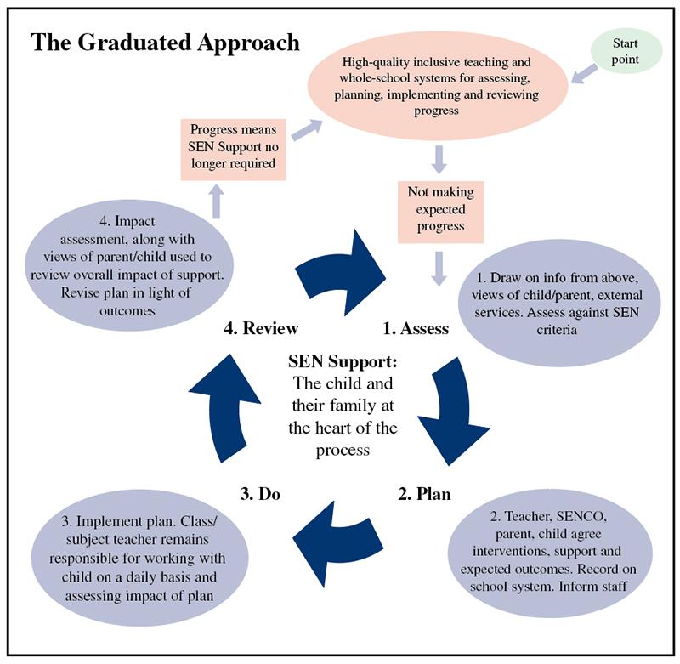
How we consult with children with SEND
The process of consultation with children is very similar with parents. We are open and honest about the needs of the child whilst taking into consideration the views of the class teacher and the parents. Every child is different and therefore we consult with each child in a different way, appropriate to their needs.
We aim for the children in our school to take responsibility for themselves, supporting them to become independent young adults and beginning to give them the tools to lead fulfilling adult lives.
Wherever possible we consult with the child about their needs and make this an open and honest conversation between them, their parents and the school. We honour the wishes of parents in this where possible but may advise that some consultation with children may be necessary, taking into account age and level of need.
At Penponds School the parents and children have been involved in reviewing and implementing the provision needed for them and their child. They have been involved in meetings with the SENCO and class teacher three times this year (parents evening, reports). In addition to this, parents with children who have TAC meetings meet once a term with all the professional involved with their child. Those with statements or EHC plans have had an annual or 6 monthly review
Graduated approach to teaching and identifying children with SEN
Quality first teaching
Differentiated learning
Feedback on achievements and next steps
Relationships
Quality learning environment
Parental involvement

Outside Agency involvement
SAFs team to refer to professionals
Professionals to provide support/ training
Review impact
Action solutions

First teachi

Quality first teaching

The Unique child

SLT Team
Identifying gaps from data
Exploring ‘at risk’ children
Reviewing impact

SEN Team
Create IEP’s with pupils and parents
Case studies for children
Liaise between teacher/parent/ child and OA
Set up interventions (and review)
Access further training and support

How we support children moving between phases of education
At Penponds Primary School we pride ourselves on the transition in place for each child. We have strong links with our feeder nursery and also the local secondary school. The children from our school come from and go to many schools in our local area. No matter the school we aim for the transition to be as smooth and supportive as possible.
Moving into Reception from nursery school:
In the summer term, each year, our reception teacher will set up visits to each Early Years setting that has children who have been allocated to our school. The reception teacher will liase closely with the EY setting and any external agencies to ensure plans are made for a smooth transition into Year R. As well as this, new children are invited into school for ‘stay and play’ sessions on 6 Friday afternoons in the summer to get the children used to the school. Parent information evenings and meetings are arranged on a 1-1 basis and a carefully structured 3 week transition in September settles the children into ‘big’ school. Further home visits are arranged in September for the reception teacher to visit each child’s home to further ensure a good start.
Moving to Secondary School:
During the summer term transition days are arranged for our children to visit their new secondary school. The SENDCo and head of Year 7 from Camborne Science and International Academy meet with our school SENDCo and class teachers to discuss every child. There are also additional transition days and visits that are arranged with the secondary schools for children who may need additional support in this move.
Our approach to teaching children with SEND (provision)
Class teacher’s have the responsibility for enabling all pupils to learn. To achieve this they:
- plan appropriate work and activities for the children they teach
- ensure that support is available for all children, this is inclusive of quality first teaching
- differentiate the curriculum to take into account different learning styles, interests and abilities
- monitor individual progress
- celebrate achievement
- identify those children who require additional or different support in order to make progress
- set targets, action plans or IEP’s and discuss this with parents, children and school SENCo
All teachers are familiar with the relevant equal opportunities legislation covering the protected characteristics: race, gender, disability, sexual orientation, religion or belief and age. (See our school website: Anti-Discrimination policy)

Support staff:
- through quality first teaching, support the teachers in enabling all children to access their learning
- support the teachers in enabling children with SEND to have access to an appropriate curriculum
- encourage and promote independence in children
- liaise with the class or set teacher
- lead interventions to close the gap for children experiencing difficulties
- promote inclusion of all children in all aspects of life at school

How adaptations are made to the curriculum and learning environment for children with SEND
Our inclusive approach to provision means that the majority of children have their needs met by accessing levelled planning that is used across the school to ensure that all lessons are appropriately differentiated. Lessons are structure to provide a range of activities taking into account learning styles such as visual, auditory and kinaesthetic. The school adopts a flexible approach to support provision in order that a child’s individual needs can be met. The support provided falls into two categories:
- direct or indirect support in the classroom
- focused withdrawal support
We encourage the emphasis on learning being within peer groups, although the needs of the pupils are considered individually.
How we enable pupils with SEND to engage in activities:
The provision in our school and our tailored curriculum enables children, no matter their need, to engage in all activities. There are some circumstances that consultation with parents may be needed and adaptions made to support the child. This is always done in consultation with the class teacher, SENDCo and parents where necessary.
How we support the emotional, mental and social development of pupils with SEND:
We support the emotional, mental and social development of children with SEND by providing extra pastoral support arrangements for listening to their views using our trauma informed school trained staff. We implement measures to prevent bullying by allocating buddies to our new pupils and have play leaders at all playtimes. We make provision for pupils’ spiritual, moral, social and cultural development which is engrained into all our curriculum, we also have weekly PSED lessons.

How we use external services to support children with SEND:
When a child is demonstrating further cause for concern or their learning need is more complex and persistent than can be met by the school interventions already put in place, school will engage with relevant external services. This is triggered when:
- a child continues not to make adequate progress
- continues working at levels substantially below that of children of a similar age even when teaching approaches have been targeted on an identified area of weakness
- continues to have difficulty in developing Literacy and Numeracy skills
- has emotional or behavioural difficulties which substantially or regularly interfere with the child’s own learning or that of the other learners, despite taking part in an individualised behaviour management programme
- has sensory or physical needs and require additional specialist equipment or require regular advice or visits by a specialist service
- has on-going communication or interaction difficulties that impede the development of social relationships and cause substantial barriers to learning
- a child’s learning needs are manifesting themselves either in a more complex or in a more specific way as they move on through the school
For these children, the difference between their attainment and that of the other children is widening and this needs further investigation.
A request for support from external services is likely to follow a decision taken jointly by school staff in consultation with parents. In seeking the support of external support services, those visiting the school will need to have access to the child’s records in order to establish which strategies have already been tried and parental permission must be given.
The external specialist may:
- act in an advisory capacity to refine targets set by the school
- extend the expertise of the teaching staff
- provide additional assessment
- be involved in supporting the child directly
- suggest that a statutory assessment is advisable
- consult with all parties involved with the child
- signpost or deliver training that supports staff in supporting the child
External agencies
The advice and support has been sought from the following agencies over this academic year:
Educational psychologist- Julie Wakely and Kate Hornblower
Early Help Hub - Supporting Change in Partnership – Kay Elliott
Family support worker- Lynne Hoon
Diabetes Nurse
Occupational therapist
Speech and language therapist- Rachel Yellhand
School Nurse- Sarah Myers
Dyslexia support service- Sandra Page
Epilepsy Nurse
Health weight team
Clear- music therapist
Adoption agency- Lydia
Sensory and attachment training
Dreadnought
Autism team

Learning Assistants are assigned across the whole school to support SEND pupils according to need. Links with outside agencies are well established and transition to and from our feeder and transfer schools is very good due to our close liaison with these schools. Colleagues from outside agencies and parent partners continue to advise and support our Staff to better understand and address the needs of our pupils.
Deployment of staff and resources
Special education needs provision is addressed by all staff on a daily basis, however; over the course of the last year we have focussed on the following key areas:
Leading intervention groups - Read Write INC phonics (Emma Wills)
- 1/3 space learning- maths (Adam Richards)
-Nessy (Adam Richards)
- Handwriting (Emma Wills)
- Read Write INC spelling (KS2 staff)
- Fun Fit (Trudy Watts)
Supporting teachers in class- running interventions
One to one provision for children with an EHC plan as allocated by their plan
Small group booster or pre-teach lessons.
Trauma informed school time to talk one to one provision weekly
Dyslexia Champion
Autism Champion
Learning environment to support children with SEN
Dyslexia friendly resources
Sensory toys
Phonics equipment
TIS areas
Enabling environments (resources for all lessons available)
Chairs/ equipment according to need
Resources as recommended by specialists.
Staff Training
Dyslexia screening | SENCO network meetings | Sensory disorder training
Dyslexia friendly schools | National SENCO award | Downs syndrome
Read Write INC | Rainbow Mat cluster support | Autism champion
Phonological Awareness interventions | Team Teach-positive handling | Dyslexia champion
epi pen administration | Attachment training

Further Support: Education, Health Care Plan (EHCP)
When a child is demonstrating a significant cause for concern or their learning need is more complex and persistent than can be met by the interventions already put in place statutory assessment will be considered. The EHC Plan incorporates all information about the child from birth to 25. All parties, including health and other agencies involved with the child contribute to this plan. If a Statutory Assessment is required the school, in consultation with the child, parents and outside agencies, will submit reports for consideration by the Local Authority’s Provision Panel. The request is made to the Local Authority (LA), which in our case is Cornwall.
The Local Authority will need to have:
- information about the child’s progress over time
- documentation in relation to the special educational need
- details of action taken by the school to meet the child’s special educational needs
- particulars of any special resources or arrangements put in place.
This information includes where relevant:-
- Provision maps and targets
- records of regular reviews and their outcomes
- health reports, including medical history where relevant
- national assessment levels and reports or records of progress complied by the teachers
- educational and other assessments, for example from an advisory teacher or an Educational Psychologist
- reports from other professionals involved with the child (Social Services, Educational Welfare services, Health and Education services).
The views of the parent and child are sought. Parents may also make a Request for Statutory Assessment. They will need to contact the Parent Partnership Service at the Local Education Office to be advised of the way forward. If the school makes a Request for Statutory Assessment, parents can still access the Parent Partnership Services at any point in the process. The process is defined by a specific timescale and statutory procedures. All of the evidence is gathered and sent to the Local Authority Special Educational Needs Officer who in turn sends it for review to the Special Educational Needs Panel. If the request is successful, then further evidence is gathered from all of the agencies who have involvement with the child. If the Provision Panel agrees to the need for an ‘Education Health Care Plan’, the Local Authority will lead on the process. School will prepare the necessary documentation and send it to the Local Authority. EHC Plans are subject to annual review which will include parental views about the child’s progress. Further reviews can be arranged at any time if significant concerns arise.
Our arrangements for handling complaints:
We hope that complaints about SEND provision will be rare, however, if there should be a concern the process outlined in the school’s Complaints policy should be followed.
How to contact us:
Headteacher – Mr Adam Richards
SENDCo – Miss Lauren Berry
SEND Governor – Mr Treve Harvey
Or by the school office: 01209 713929
Penponds Primary School, Higher Penponds, Camborne, TR14 0QN
Local and School Offer:
Please see our school website for our School Offer and a link to the LA Local Offer

