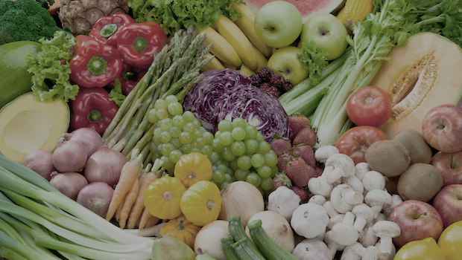

**How you can help your child:**

* Try growing some fruits and vegetables at home. Cress, spinach, lettuce and radishes are quite fast growing and you can grow them on a windowsill
* Encourage your child to try new fruit and veg- have a look at the range in shops and try them at home. Talk about where they have come from, are they native to the UK or from abroad?
* Prepare them for the Eden project camp with a pre visit. This will help their learning in school even if they are not going on camp.

**Computing**

* E-safety
* Powerpoint

This will be taught by Miss Meyers and Miss Percy

**Non-Fiction**

* Instructions
* Explanations

**Drama**

* Talk for Writing
* Debating
* Performance of Jack and the Beanstalk: The Prequel

**Geography – Food Glorious Food**

* Local farming
* Food miles and the environmental impact
* Conditions for growth
* Developing the school garden

The main topic input will be from Mrs Treen

**Poetry**

* Poetry about seeds and growth

**Literacy**

**Fiction:**

* Story-telling- Jack and the Beanstalk: The Prequel
* Writing narrative with speech
* Developing characters and settings

**Texts:**

* Jack and the Beanstalk: The Prequel

**Science – Magnets and springs**

* Attraction and repelling
* North and south poles
* Using springs and magnets in ‘real life’ situations
* Forces and energy

Science will be taught by Miss Percy on Thursday afternoons

**Trencrom Class –**

**Year 3/4 Summer test (1st half)**

**Food Glorious Food**

**Geography and Science**

**Maths**

* Place value of numbers up to 1000 (10,000 for year 4)
* Addition and subtraction using place value
* Addition and subtraction using written methods such as number lines and columns
* Number bonds to 20 and 100
* Multiplication and division of 2 and 3 digit numbers.
* Properties of shapes
* Identifying angles, parallel and perpendicular lines
* Finding fractions of shapes and numbers, placing fractions on a number line.

**PE –**

Athletics and cricket

This will be taught on a Monday afternoon by Mrs Watts and Mr Rodda

**Music – developing musical instruments**

* Ukelele lessons

This will be taught by Mr Field, a music specialist

**RE – Islam**

This will be taught by Miss Meyers

**D&T – cookery**

Exploring different fruit and vegetables

(Main D&T will be after half term)

**Art – block printing**

* Shape and details in fruit
* Block print making

This will be taught by Mrs Treen

**PHSE –**

e-safety, friendships and getting on, feelings and being kind